Dear Parents and Carers,

**Head Teacher’s Comments**

**Christmas Week with d’Auvergne**

As the term comes to a close, we move towards many of the highlights.

On Monday at 5.30pm we have our whole school / family gathering around the Christmas Tree for our Christmas Sing-a-Long. EVERYONE is welcome to join the d’Auvergne team for mince pies / hot chocolates, candles, carol karaoke and camaraderie. Lasting about 45 minutes, it is a lovely evening and very much a d’Auvergne tradition. The weather looks promising, but do wrap up!

On Tuesday, Key Stage 1 will be performing their Nativity at 2pm and 5.30pm to family and friends.

On Wednesday, Reception will be singing to their special guests at 2pm.

Also on Wednesday, St. Mark’s Church will be packed by our Key Stage 2 community for our very special Carol Service. Tickets for the service will be distributed on Monday – every family will get at least 1, with 2 tickets definitely available for Year 5, Year 6 and those performing special pieces.

On Thursday, Nursery will conclude the festive events as they will be singing to their special guests at 9.00am.

On Thursday afternoon, we shall be celebrating, in the usual fashion, our termly award winners in our Achievers’ Assembly at 1.30pm.

There will be no After School Club on Thursday, but there will be a PTA Tuck Shop.

**Raffle Tickets**

Any unsold raffle tickets are to be returned on Monday. If you wish to sell more tickets, please collect from school this afternoon or on Monday – THANK YOU!

**Vernon the Bear**

Thank you to all who offered a suggestion for our new school mascot. Following much deliberation, your PTA chose ‘Vernon’ for the name of our d’Auvergne Bear. Well done to **Lucas Lopes and Evie Kyle** who both selected the name.

**MLL Christmas celebrations in d’Auvergne – A Message from Mrs Kruk**

As every year in d'Auvergne, this December we are engaging in Christmas celebrations with a multilingual and multicultural aspect. The children in KS2 will be singing carols in Portuguese and Polish during the Christmas Service at St Mark’s Church. In French lessons we will be singing ‘Jingle bells' in French and in language clubs the participants will have a go with performing the same carol in Romanian and Polish.

In our multicultural club today, we prepared Origami Christmas decorations. It has also been an opportunity to learn a little bit about Japanese culture - ripe with unique and intriguing ideas - and celebrate a heritage of one of our multilingual staff in school. Making Origami pieces makes people more attentive and thoughtful - a very useful state of mind to be able to reach.

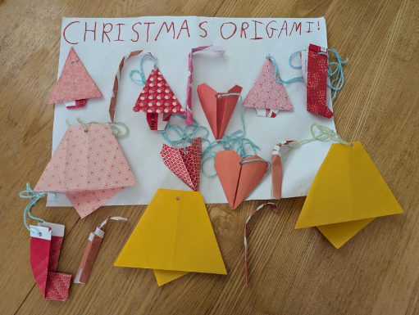

**Philosophical question in home languages to remind about the importance of speaking our home languages with our children:**

Do you think time ever stops?

Você acha que o tempo para?

Czy myślisz, że czas się kiedykolwiek zatrzymuje?

**Bentley School Photographs**

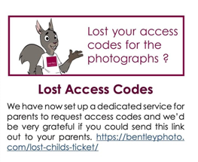

**“Discover Crafty Christmas” at Jersey Museum, Saturday 14th December, 10am - 4pm**

This Saturday 14th December, put on your best Christmas jumper and head down to Jersey Museum to create FREE fun festive crafts! Make snow globes, Christmas cards and decorations for the holidays. Follow the festive food trail around 'Bouan Appétit!', stir a Christmas pudding and make a wish! Story telling starts at 10:30am and two short movies will play at 12:45am and 2:15pm in the AV Theatre, so grab some popcorn, sit back and get into the festive spirit. Join in with Christmas carols at 1:15pm in the museum entrance, with merriment and good cheer! All children must be accompanied by a helpful adult.

Mèrcie bein des fais,

Jon Brennan

Head of Education at Jersey Heritage

**Festive Forest School**

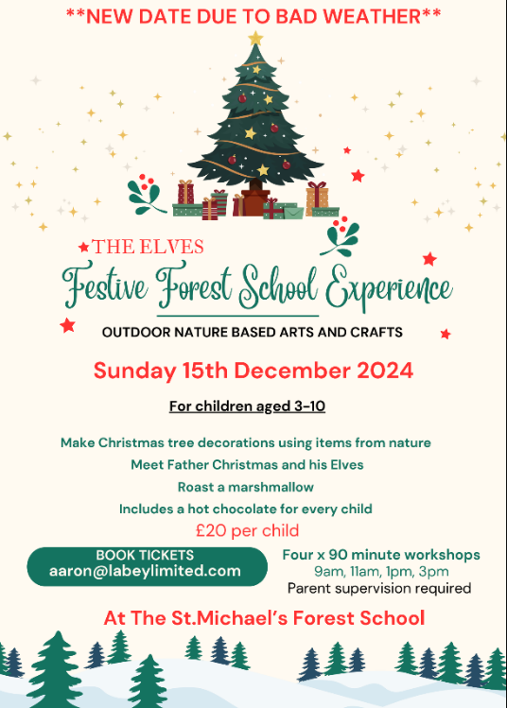

**Children and Families Hub**

The Children and Families Hub would like to share with you, their new [**live timetable of courses for parents and carers**](https://www.canva.com/design/DAGJ43j9Urs/U9b3X4a5Vc7lx1dDlMZCjA/view?utm_content=DAGJ43j9Urs&utm_campaign=designshare&utm_medium=link&utm_source=editor) for Spring 2025.

Courses range from parental wellbeing to support with ADHD and autism. Some of the courses are delivered online and others face to face in the evening or daytime (subject to requirements).

If you would like to view the courses on offer, please use the above link which is kept up to date, click on the tiles to learn more about the courses and to see when they are available. Alternatively, please view the attaching PDH document which can be printed and displayed in your school, office or home setting.

If you require any further information or would like to register for any of the courses, you can do this by emailing the [childrenandfamilieshub@gov.je](mailto:childrenandfamilieshub@gov.je) or by calling 519000. When registering your interest, please provide **your name, contact number, email address** and **child’s date of birth**.

Have a lovely weekend,

Mr Cooper

**Year Group Updates**

**Futures 1**

With Christmas fast approaching it has been a glittery, sparkly week.  The children have enjoyed making more decorations for our classroom using their fine motor pincer grip to pick up sequins and sprinkle them onto our bauble shapes.  We are all loving the Christmas tunes (especially the staff!) and have explored our instrument box for different percussive instruments to play along with.  Some of the children demonstrate such amazing rhythm!

With the dreadful weather we've had, very few of the children have wanted to be outside, so we have made great use of our climbing area to burn off some energy and work those big muscles. It's also a great work out for the staff setting it up each morning -  who needs the gym?!

Just a little reminder that next week we finish on Thursday (not Friday) and pick up is at the normal time.

Have a great weekend,

Mrs Mason & The Futures 1 Team

**Futures 2**

Happy Holidays!

The main feature this week was our trip to Jersey Zoo! We were lucky enough to have a guided session by a zookeeper, who told us all about animal classification and we were even able to feel the skins, scales and feathers of various animal types. Should you want to do some homework, we looked at: amphibians, reptiles, mammals. fish and birds.

Another highlight was the Sloth House! We were treated to two very active sloths that let us observe them up close and personal. In very specific order we saw: sloths, reptiles, gorillas, orangutans, bats, butterflies (lunch) flamingos and more sloths before heading back to school.

Due to unforeseen circumstances, our Wizard of Oz premiere may be delayed until after the school holidays. Ironically the weather may have played a factor, but we will try to get as much filming completed when the children are happy and calm... Just to prepare you, this film may have to be a January treat.

Finally, the plan is to cook many of the items that we will be eating in our end of year party. Based on the children's suggestions, next week we hope to bake a cake, set a jelly, fry chicken nuggets, rollout a pizza and assemble (?) hotdogs!

Wishing you festive cheer

The Futures 2 Team

**Nursery**

The penultimate week in Nursery - the end of our very first term, well done! The children have made such fabulous progress and we are so proud of how far they have come since September. Please keep working on their**independence** over the Christmas holidays, the cold weather will bring the perfect opportunity for the children to keep perfecting their coat flip trick!

This week we have been learning the **sound t-t-t**. Next week, we will be recapping the sounds m,a,s,d and t that we have taught so far so that the children have the opportunity to consolidate these.

We are looking forward to our **Nursery Christmas Party on Wednesday** - please remember that the children do not need to bring a lunchbox on this day as we will be providing a festive party lunch. The children are encouraged to wear their Christmas  party clothes! On **Thursday morning at 9am, the children will be performing their Christmas songs**, this will be followed by a gift giving and mince pies for parents down in the Nursery as the children have been working as hard as the elves on their crafts for you. For our performance on Thursday, the children are welcome to wear Christmas pyjamas or a festive jumper.

**Reception**

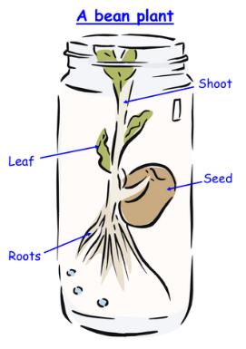What a busy week!

We have been watching our beans start to grow; we can see a root beginning to appear. The children have drawn and labelled the jar. This was our first scientific drawing, so we even learnt how to use a ruler to draw a straight line for our labels. Wow!

Don’t forget, your child’s bean will be coming home with them for the Christmas holidays. We are looking forward to seeing all their drawings and observations of their bean.

In maths, we have learning how to use a number line or a number track to count one more and one less. Keep practising this at home from any given number so children start to understand the pattern in numbers and that one number is bigger or smaller than another. E.g. 1 more than 19 is 20, 1 less than 19 is 18. Show the children how you can move forwards or backwards along the number line.

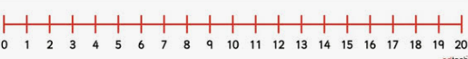

Mr Henderson, one of the Year 6 teachers and our magnificent Maths Lead, came into Reception this week to observe one of our maths sessions. He was very impressed with the learning that was taking place with our brilliant mathematicians and was excited to see how the children could talk about what they could see and what they noticed about the number 6. How many different ways can you make 6? Have a go at home.

**Monday 16th December – Reception Christmas Party.** Children can come into school dressed in party clothes for the day. Please ensure they have suitable footwear and a warm waterproof coat as normal. We will be providing some extra treats to have and enjoying a fun filled afternoon of party games.

**Wednesday 18th December – Reception Christmas singing at 2pm**. All parents and family members welcome. Children should come into school in their full d’Auvergne School uniform – **no PE Kit please**. Thank you for sending in the tinsel headbands. We need these by Monday for our rehearsal.

**Thursday 19th December** – Children should come into school in their full d’Auvergne School uniform – **no PE Kit please**.

We hope you have a lovely weekend!

Mrs Rachel Lutkin-Clarke and Mrs Jodi Tostevin (The Reception Dream Team)

[r.lutkinclarke@dauvergne.sch.je](mailto:r.lutkinclarke@dauvergne.sch.je)      [j.shurey@dauvergne.sch.je](mailto:j.shurey@dauvergne.sch.je)

**Year 1**

We have had another busy week! Our Nativity rehearsals are in full swing, and the children are very excited for you all to come and see them perform next week. We have two performances on Tuesday 17th December, one at 2.00pm, and one at 5.30pm. For the evening performance, please ensure your child is back at school by 5.10pm, drop off at the classroom.

In RE, we have been developing our understanding of the Nativity by considering the feelings of different characters in the story; please ask your child about this. We think Mary was tired, fed up and her back hurt!

In Writing, we have been recording questions we would ask Father Christmas, if we got the chance. We have been starting our question sentences with a question word, and we know we use a question mark to finish.

We have been coding this week, in Computing, using the 'Scratch Jr' programme. We have really enjoyed these sessions, and our coding abilities are better than the adults!

Please have a look at this link to find out more;

<https://www.scratchjr.org/>

We have been assessing this week in RWI, so no books will go home on Friday. Your child can still choose from our interest books.

Nearly there!

Year 1 Team

**Year 2**

We have had a very productive week!

We are in full swing with our Nativity Play rehearsals which are going great! Please see parent mail for all details about the Nativity.

For our writing this week we have started planning our Apprentice write, using our Text driver book Molly Drew and the Great Fire. We will be using our own words and adding a different time traveling device of our choice to re write the story. Some great devices have already been thought of and designed ready to be included in our version of the story.

In Maths, we have been comparing length in cm and measuring mass in kilograms, the children have been estimating classroom objects and then seeing if they were correct using a ruler (cm), using the vocabulary- estimating/ comparing /shorter/ longer/shortest/ longest. We have also been looking at different weighted grams to measure the weight of classroom objects using the weighing scales, using the vocabulary- comparing / heavier/ lighter/ heaviest/lightest.

In Science, we have come to our final week looking at our bulbs and seeing the different stages of its growth since we planted them four weeks ago. We look forward to seeing them grow further next year!

Please check the parent mail regarding the KS1 Christmas party on Monday 16th.

Reminders:

Monday 16th December- 1pm-KS1 Christmas party

Monday 16th December- 5.30-6.30pm- Mince pies and carols around the tree

Tuesday 17th December -2pm and 5.30pm- Nativity performance for family and friends in the hall.

Thursday 19th December- Last day of Term.

Both Miss Aubert and Mrs Harris wish all the children and families a lovely Christmas and enjoy the holidays!

Best wishes

Mrs Harris and Miss Aubert

**Year 3**

It’s been a busy week finishing off various topics and preparing for our Christmas church service next week! The children have worked so hard on learning their lines and practicing our year group song. Thank you to parents for your support with this!

In Maths this week, we have been building on our knowledge of the 4 and 8 timestables. In writing, we have been writing our own acrostic poems about the Goddess Athena. We have been so impressed with the quality of the vocabulary that the children have been using! In reading lessons, we have been focusing on summarising and predicting.

A date for the diary:

-The Christmas Church service will be held at St Mark’s Church at 6pm. The children will need to wear their school uniform for the service.

A few notices:

-Please if you’re available to walk down to the Church with us on Monday or Tuesday morning for our rehearsals can you let us know. We’re short on volunteers particularly in 3B.

-Laptops have finally arrived! We ask that parents please encourage the children to respect this privilege. Children are expected to charge their laptops at home and bring them to school daily.

Thank you for your ongoing support.

Kind regards,

Miss Bolton and Mrs Davies

[s.bolton@dauvergne.sch.je](mailto:s.bolton@dauvergne.sch.je)     [r.davies@dauvergne.sch.je](mailto:r.davies@dauvergne.sch.je)

**Year 4**

Deadly Dragons, Cruel Creatures, Roaring Reptiles... This week we have been creating our non-chronological reports (fact files) about our own created dragons. At the start of term, children used fallen leaves to create dragons (using the leaves as their skin texture) and this week they have made their fact file about it. We are immensely impressed with the standard of writing and creativity from our budding authors.

*"The Wardweller is a fire and ground type. Being carnivorous, they eat meat, have luscious flowy wings and red, bloodstained teeth."*

*"Dragons are beautiful, majestic creatures that thread, dance and prance through the skies..."*

*"When Amythyst (the dragon) lays an egg, if it has a sun on it the baby is a girl but if it has a moon, it is a boy! And when space dragons die, they get sucked into a black hole and get thrown out into new stars!"*

These are some excerpts from the children's books and, as you can see, they flow with creativity. Creative Writing can take place anywhere, and children should have opportunities to write freely at home too.

In Science, children have investigated the benefits of being **vertebrate** or **invertebrate** animals. They created creatures out of wood (vertebrate) or string (invertebrate) and described how they would move and survive in their habitat/environment. The children loved this task where, again, they could use their creativity to explore a key scientific principle of animal classification.

In other areas, children are practising their hearts out in poetry. We really think you will be impressed with their singing and poetry performance at the church next week. History, children have given their own thoughts as to a Roman creation story which could be similar or different to the story of Romulus, Remus, and the Wolf.

[k.french@dauvergne.sch.je](mailto:k.french@dauvergne.sch.je)

[l.dufeu@dauvergne.sch.je](mailto:l.dufeu@dauvergne.sch.je)

[r.blake@dauvergne.sch.je](mailto:r.blake@dauvergne.sch.je)

**Year 5**

It has been a super last full week of term in Year 5!

In our English lessons we have written a diary entry based upon Marcy and our text driver book. The children planned this independently and then wrote their own diary entries using these plans. They have then edited their work using purple pens! Next term, we will be focussing upon narrative writing and our new text driver book. In our Reading lessons, we have nearly finished our class Poppy Pym book and are focussing heavily upon synonyms and antonyms at the moment together with dictionary skills. We have also been working hard on Bug Club. Please can this be encouraged at home so the children are moving up their bands levels as we approach the end of term. Please can we also remind adults to encourage their children to bring their library books in each week to be changed in our library time on a Friday. A number of children are not bringing these in each week or using the library resources to its full potential.

In Maths, we have worked upon division with and without a remainder. It is vital the children have strong timestable knowledge for this work so please encourage them to continue to access TTRS and accessing Maths Tutor at home on a weekly basis, Mathletics is no longer being used.

We also had a super session with Mrs Willis this week with our Lino cutting in Art! The children have made their own Egyptian art designs which they will then use as printing designs next term. The children also enjoyed their last swimming session on Thursday morning-well done Year 5!

Next week, we have a busy last four days with Church rehearsals and lots of Christmas fun! We hope to see many of you at our Christmas Carols around the tree evening on Monday night and at our School Carol Service on Wednesday evening.

Have a super weekend!

Mr Worthington and Miss Condlyffe

[a.worthington@dauvergne.sch.je](mailto:a.worthington@dauvergne.sch.je)            [s.condlyffe@dauvergne.sch.je](mailto:s.condlyffe@dauvergne.sch.je)

**Year 6**

In Year 6 this week we have had a brilliant final full week of term. The children have got right back into the swing of their 'normal' learning. On Monday, they had a reflection session with Mrs Willis on all of last week's adventures, creating some amazing Art and Writing pieces. In Writing, the children have delved into Victorina Ghost narratives, and they will begin writing their own after the Christmas break. In Science, the children have Undertaken their 'Finches Investigation' by channelling their inner Charles Darwin.

A few gentle reminders:

* Please ensure your child brings their library books to and from school every day.
* **Our PE days remain Monday and Wednesday. Coach Rob will teach the children on Wednesday, and the children will have a PE session with their class teacher on the Monday.**
* Laptops need to be brought in to school every day fully charged. We have MakerSpace this half term and the children will need their laptops for these sessions.
* The children have come home with their poem 'Little Tree' for the Christmas church service. We will be practicing this throughout next week. If the children can continue to practice this throughout the weekend and early next week, that would be greatly appreciated.

Home Learning

Reading: Daily for 20 minutes.

Spellings: Practice daily. Spellings can be found on Google Classroom or on the physical handout.

Maths: Complete Maths Tutor - Fractions and Decimals course. If your child needs help assigning this, please contact their class teacher.

Maths: Arithmetic paper practice - refer to google classroom for support and videos.

Achievers:

The achiever in 6G this week is Byanca. She has been an enthusiastic and committed learner throughout the week. She has really come out of her shell recently and it is lovely to see her taking such great pride in all of her work. Not only this but she is always a support friend to all of her peers. Well done Byanca!

The achiever in 6H this week is Marc. This young man has not only had a fantastic week but has had a terrific first term in Year 6. He is kind and helpful to his peers but during PE this week Marc has been an especially good teammate. Always encouraging others even if they make mistakes. This is a wonderful quality to have, and it shows how mature Marc is! Great job - keep it up!